|  |  |  |  |  |  |  |  |  |  |  |  |
| --- | --- | --- | --- | --- | --- | --- | --- | --- | --- | --- | --- |
|  |  |  |  |  |  |  |  |  |  |  |  |
|  |  | | | **Protokół projektu układu testującego lokalizację trilateracją w systemie Człowiek za burtą przy użyciu UWB** | | | | | | Data wystawienia: | |
|  |  | |
|  | Doc# | 3/CZB/004 |
|  | Nr wniosku NCBR: | | POIR.01.01.01-00-0196/19 | | | Nazwa projektu: | | Smart Yacht |
|  | Rozpoczęcie testów: | |  | | Zakończenie testów: | |  | |

#### Założenia

Celem jest zbudowanie układu testującego metodę trilateracji UWB. Układ ma się składać z dwóch urządzeń- inicjatora wyposażonego w wyświetlacz LCD do wyświetlania dystansu oraz respondera- urządzenia mającego odpowiadać na ramkę inicjatora.

#### Hardware

* 1. Inicjator

Układ inicjatora składa się z płytki Nucleo-64 z mikrokontrolerem STM32F103 do której podłączony został shield DWS1000 wyposażony w moduł DWM1000 marki Quorvo. Całość została podłączona do wyświetlacza alfanumerycznego 16x2 przy pomocy płytki prototypowej. Całość może zostać zasilona z gniazda USB bądź z power banka.

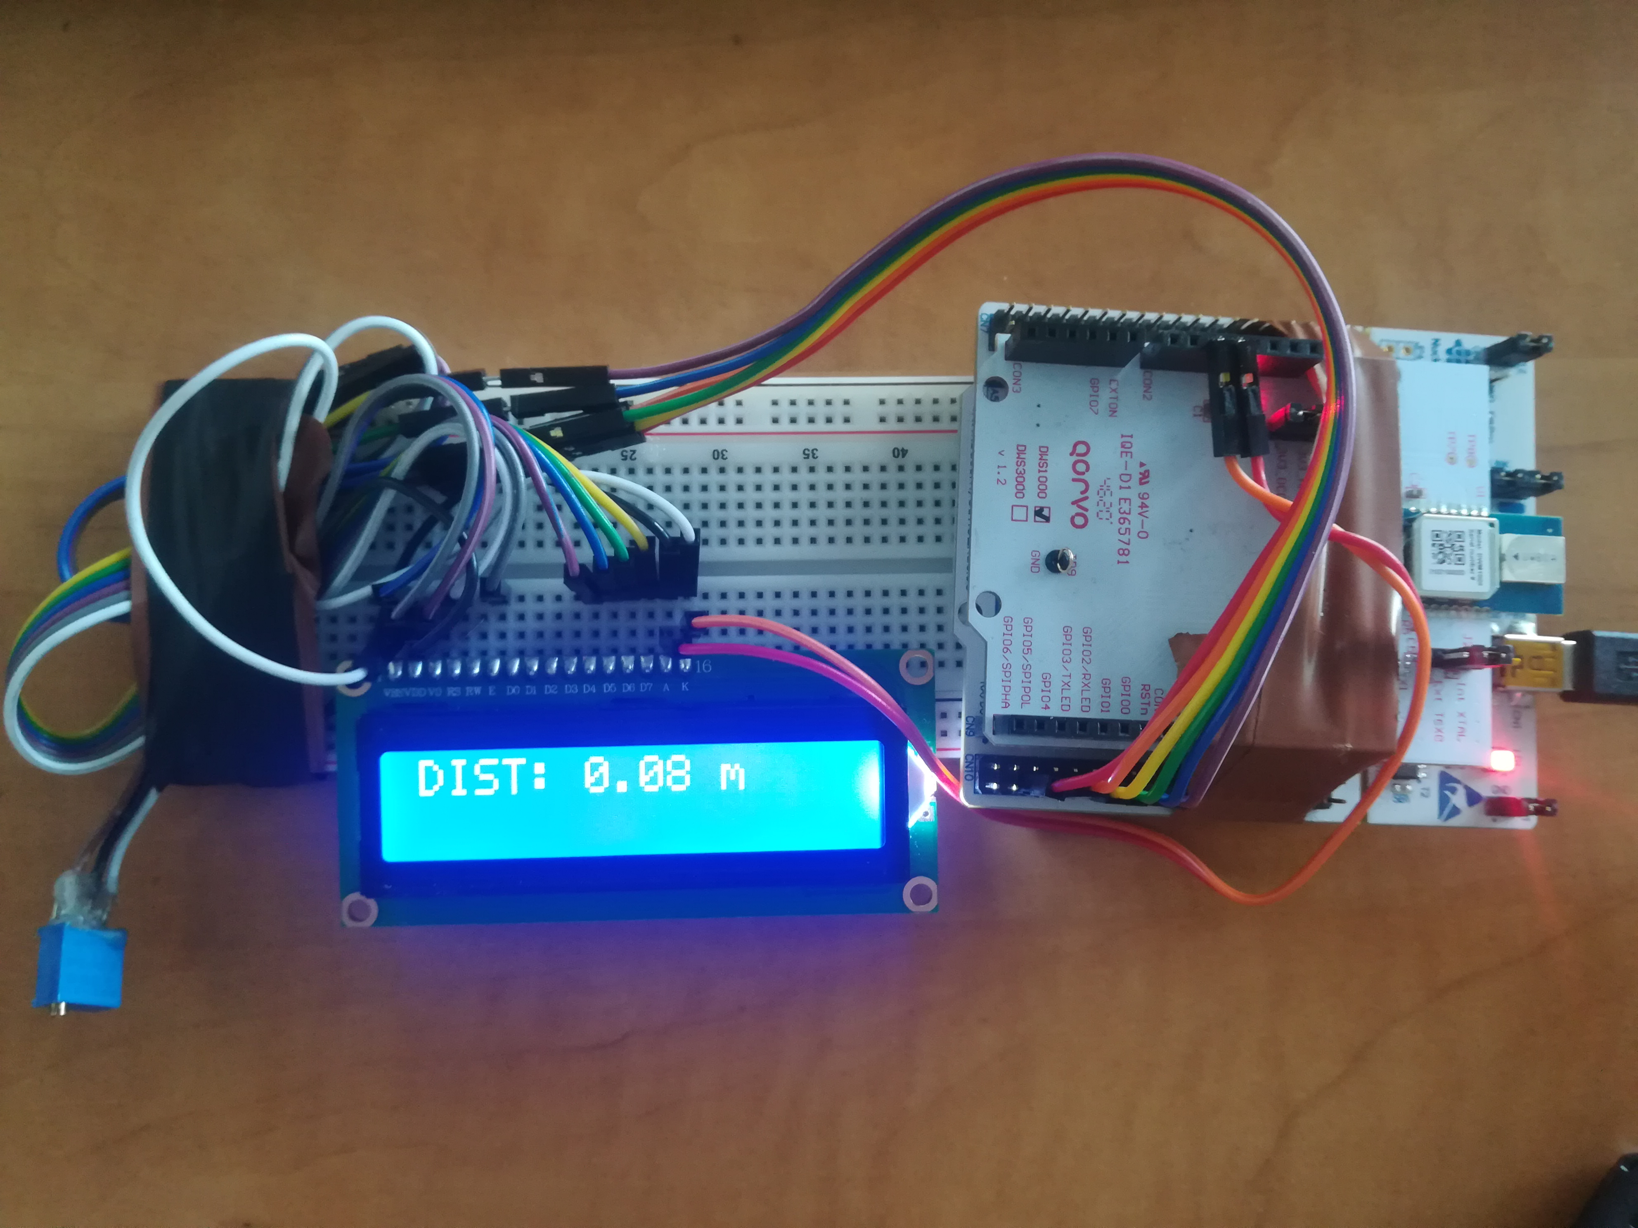

Figura 1: Układ inicjatora

* 1. Responder

Jako urządzenie lokalizowane posłużył analogiczny układ, składający się z płytki nucleo-64 z mikrokontrolerem STM32L010RBT wyposażony w ten sam shield(DWS1000).

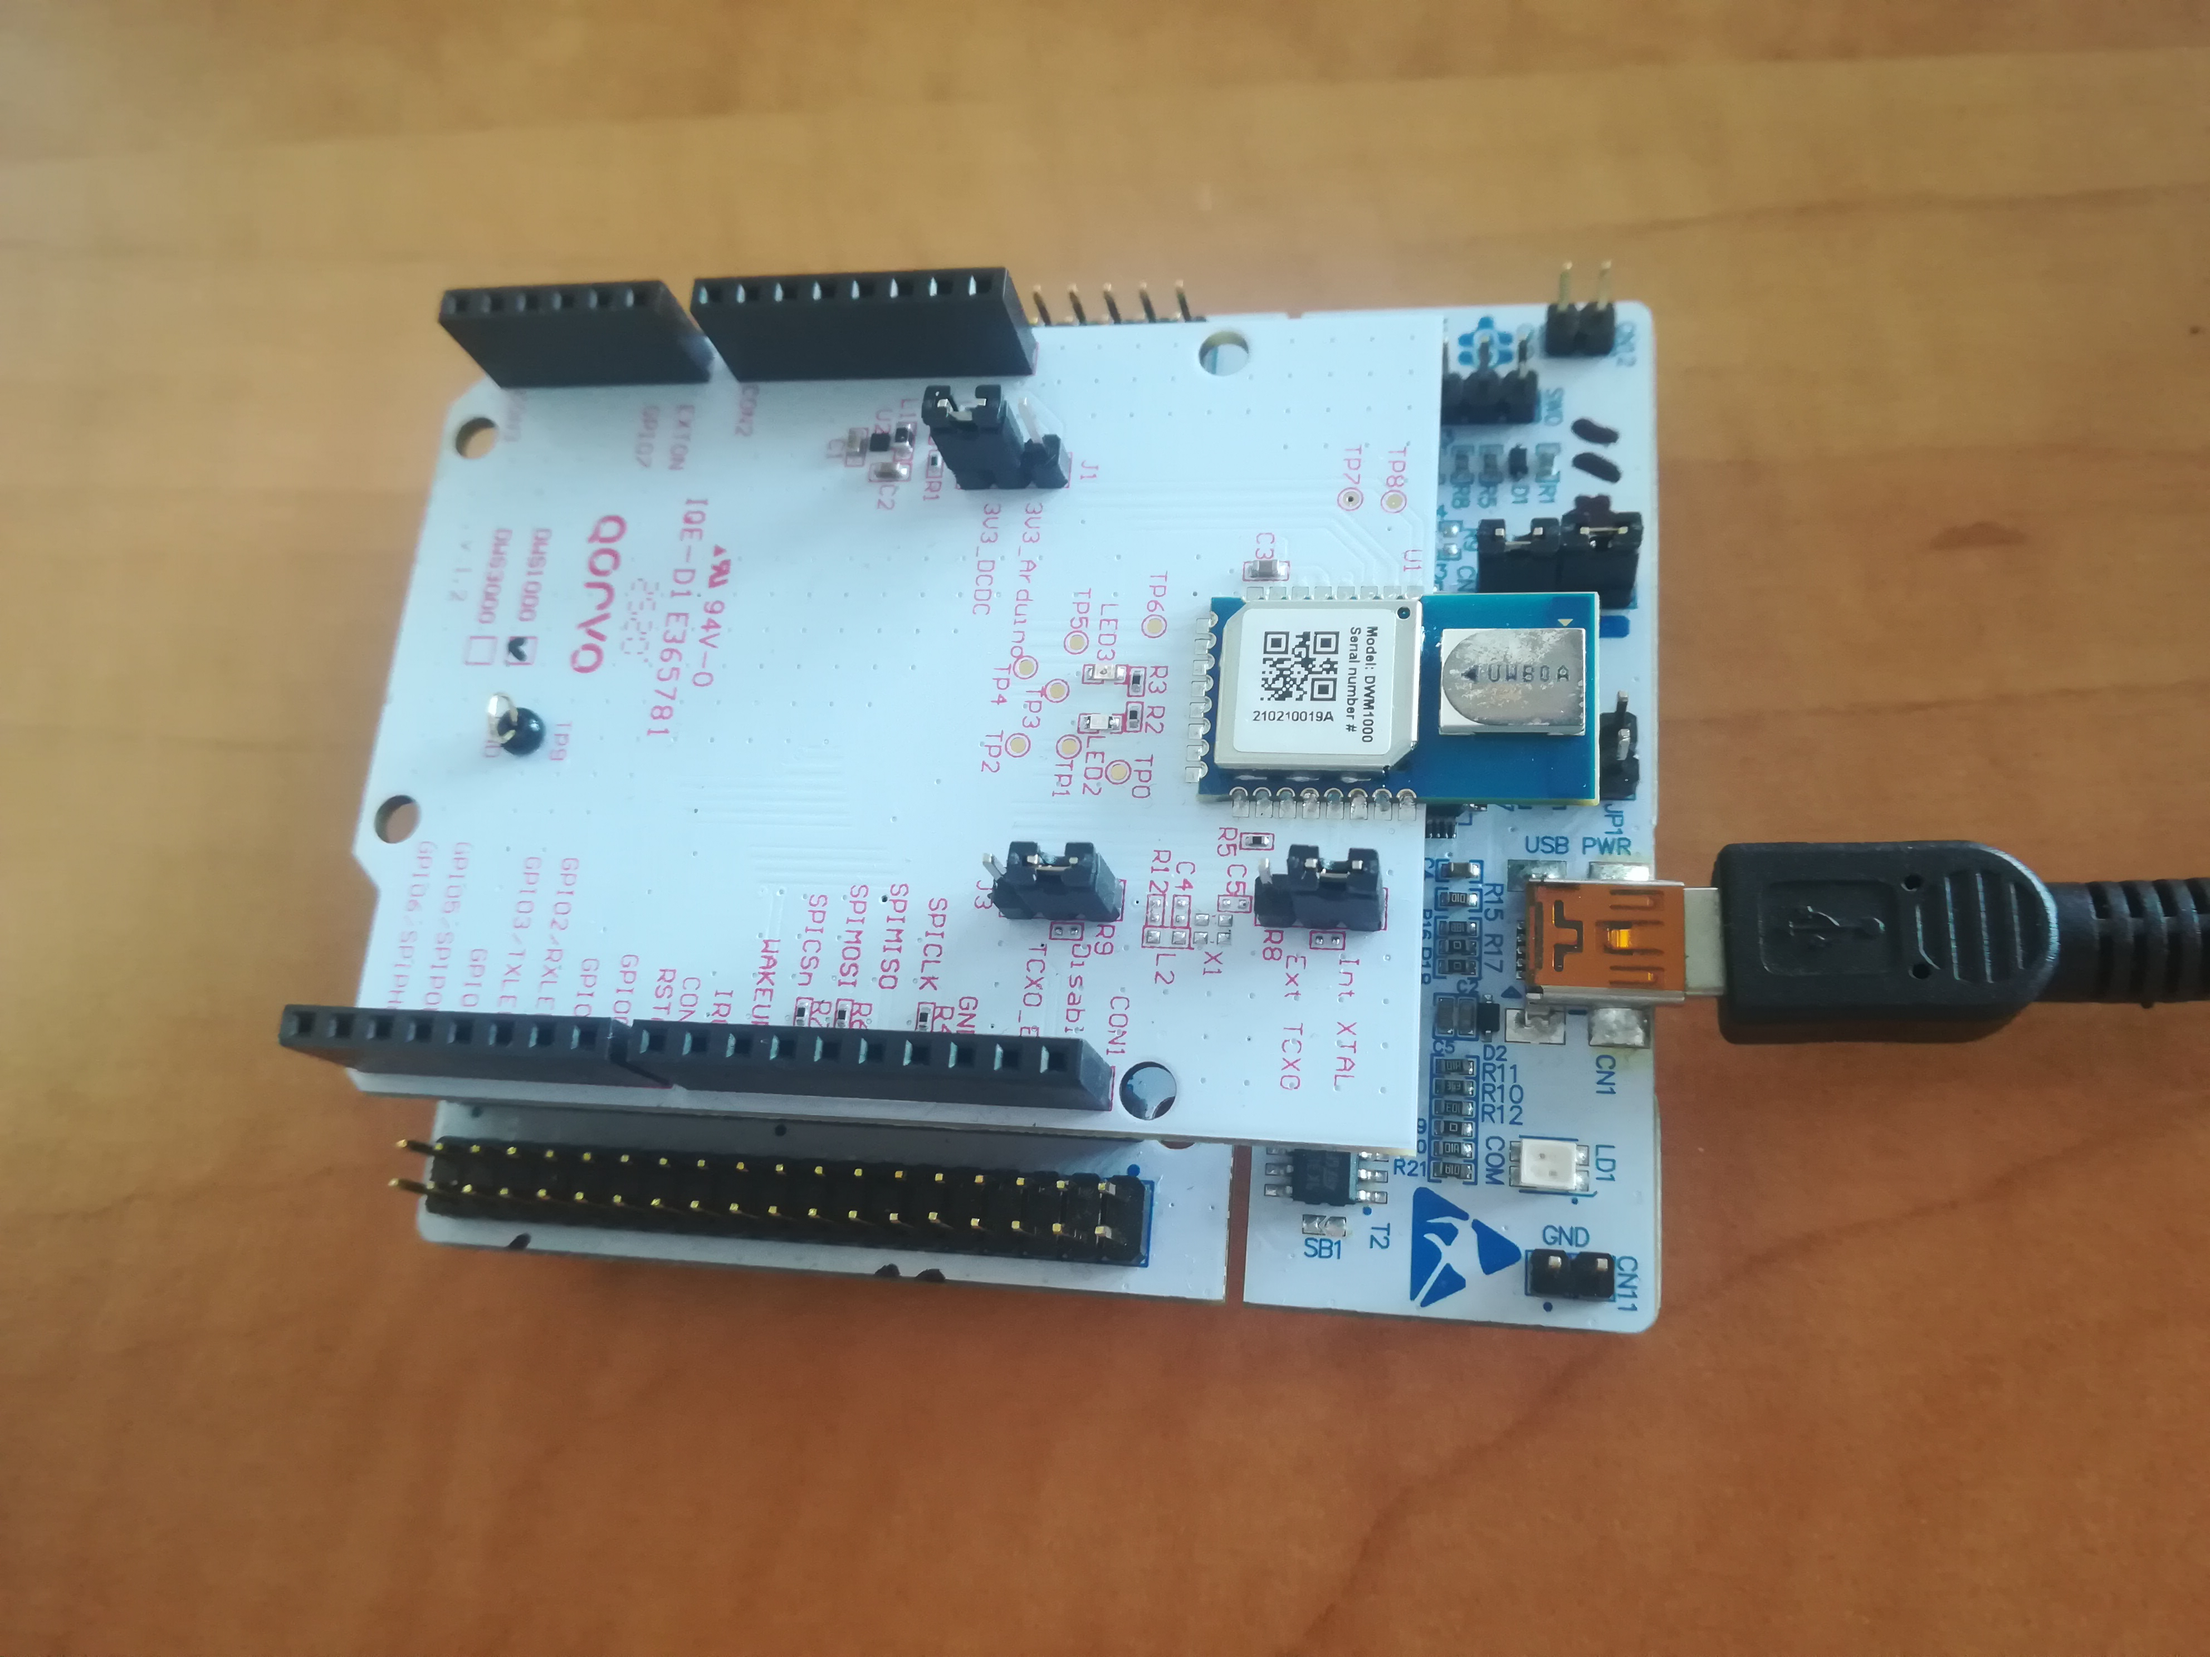Figura 2: Układ respondera

#### Software

Oprogramowanie testowe to kod przykładowy współpracujący z firmware od producenta układu UWB. Przykład został zmodyfikowany ze względu na użycie innych mikrokontrolerów niż w przykładnie.

Wybrane przykłady są częścią paczki DWS_1000_ExampleCode_v1.0.1.

* 1. Inicjator

Kod inicjatora bazuje na przykładzie ex_06a_ss_twr_init z wprowadzonymi modyfikacjami.

Dyrektywa RESP_RX_TIMEOUT_UUS jest czasem oczekiwania na odpowiedź respondera. Został on zwiększony z 210 do 1000us.

Dyrektywa RNG_DELAY_MS jest interwałem pomiędzy wysyłanymi do respondera żądaniami. Został on zwiększony z 1000 do 2000ms.

Dyrektywa UUS_TO_DWT_TIME jest mnożnikiem konwertującym czas. Ponieważ docelowy MCU jest wolniejszy niż ten w przykładzie, wartość została zmieniona z 65536 na 147456

Dodana została również obsługa wyświetlacza alfanumerycznego.

Pinout został ustawiony zgodnie z przykładem i shieldem DWS1000.

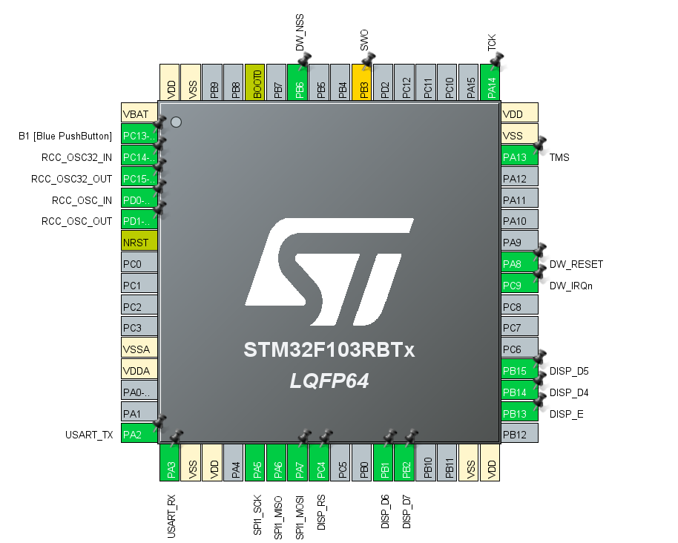Figura 3: Pinout inicjatora

Kod główny(main.c):

/* USER CODE BEGIN Header */

/**

******************************************************************************

* @file : main.c

* @brief : Main program body

******************************************************************************

* @attention

*

* <h2><center>&copy; Copyright (c) 2021 STMicroelectronics.

* All rights reserved.</center></h2>

*

* This software component is licensed by ST under BSD 3-Clause license,

* the "License"; You may not use this file except in compliance with the

* License. You may obtain a copy of the License at:

* opensource.org/licenses/BSD-3-Clause

*

******************************************************************************

*/

/* USER CODE END Header */

/* Includes ------------------------------------------------------------------*/

**#include** "main.h"

/* Private includes ----------------------------------------------------------*/

/* USER CODE BEGIN Includes */

//main ex

**#include** "platform/port.h"

**app_t** app;

//end of main ex

**#include** <stdio.h>

**#include** <string.h>

**#include** "decadriver/deca_device_api.h"

**#include** "decadriver/deca_regs.h"

**#include** "platform/stdio.h"

**#include** "platform/deca_spi.h"

**#include** "platform/port.h"

**#include** "../Display/an_disp.h"

/* USER CODE END Includes */

/* Private typedef -----------------------------------------------------------*/

/* USER CODE BEGIN PTD */

/* USER CODE END PTD */

/* Private define ------------------------------------------------------------*/

/* USER CODE BEGIN PD */

/* USER CODE END PD */

/* Private macro -------------------------------------------------------------*/

/* USER CODE BEGIN PM */

/* USER CODE END PM */

/* Private variables ---------------------------------------------------------*/

**SPI_HandleTypeDef** hspi1;

**UART_HandleTypeDef** huart2;

/* USER CODE BEGIN PV */

/* USER CODE END PV */

/* Private function prototypes -----------------------------------------------*/

**void** **SystemClock_Config**(**void**);

**static** **void** **MX_GPIO_Init**(**void**);

**static** **void** **MX_USART2_UART_Init**(**void**);

**static** **void** **MX_SPI1_Init**(**void**);

/* USER CODE BEGIN PFP */

/* USER CODE END PFP */

/* Private user code ---------------------------------------------------------*/

/* USER CODE BEGIN 0 */

/* Example application name and version to display. */

**#define** **APP_NAME** "SS TWR INIT v1.3\r\n"

/* Inter-ranging delay period, in milliseconds. */

**#define** **RNG_DELAY_MS** 2000

/* Default communication configuration. We use here EVK1000's mode 4. See NOTE 1 below. */

**static** **dwt_config_t** config = {

2, /* Channel number. */

DWT_PRF_64M, /* Pulse repetition frequency. */

DWT_PLEN_128, /* Preamble length. Used in TX only. */

DWT_PAC8, /* Preamble acquisition chunk size. Used in RX only. */

9, /* TX preamble code. Used in TX only. */

9, /* RX preamble code. Used in RX only. */

0, /* 0 to use standard SFD, 1 to use non-standard SFD. */

DWT_BR_6M8, /* Data rate. */

DWT_PHRMODE_STD, /* PHY header mode. */

(129 + 8 - 8) /* SFD timeout (preamble length + 1 + SFD length - PAC size). Used in RX only. */

};

/* Default antenna delay values for 64 MHz PRF. See NOTE 2 below. */

**#define** **TX_ANT_DLY** 16505

**#define** **RX_ANT_DLY** 16505

/* Frames used in the ranging process. See NOTE 3 below. */

**static** **uint8** tx_poll_msg[] = {0x41, 0x88, 0, 0xCA, 0xDE, 'W', 'A', 'V', 'E', 0xE0, 0, 0};

**static** **uint8** rx_resp_msg[] = {0x41, 0x88, 0, 0xCA, 0xDE, 'V', 'E', 'W', 'A', 0xE1, 0, 0, 0, 0, 0, 0, 0, 0, 0, 0};

/* Length of the common part of the message (up to and including the function code, see NOTE 3 below). */

**#define** **ALL_MSG_COMMON_LEN** 10

/* Indexes to access some of the fields in the frames defined above. */

**#define** **ALL_MSG_SN_IDX** 2

**#define** **RESP_MSG_POLL_RX_TS_IDX** 10

**#define** **RESP_MSG_RESP_TX_TS_IDX** 14

**#define** **RESP_MSG_TS_LEN** 4

/* Frame sequence number, incremented after each transmission. */

**static** **uint8** frame_seq_nb = 0;

/* Buffer to store received response message.

* Its size is adjusted to longest frame that this example code is supposed to handle. */

**#define** **RX_BUF_LEN** 20

**static** **uint8** rx_buffer[RX_BUF_LEN];

/* Hold copy of status register state here for reference so that it can be examined at a debug breakpoint. */

**static** **uint32** status_reg = 0;

/* UWB microsecond (uus) to device time unit (dtu, around 15.65 ps) conversion factor.

* 1 uus = 512 / 499.2 µs and 1 µs = 499.2 * 128 dtu. */

**#define** **UUS_TO_DWT_TIME** 147456

/* Delay between frames, in UWB microseconds. See NOTE 1 below. */

**#define** **POLL_TX_TO_RESP_RX_DLY_UUS** 140

/* Receive response timeout. See NOTE 5 below. */

**#define** **RESP_RX_TIMEOUT_UUS** 1000

/* Speed of light in air, in metres per second. */

**#define** **SPEED_OF_LIGHT** 299702547

/* Hold copies of computed time of flight and distance here for reference so that it can be examined at a debug breakpoint. */

**static** **double** tof;

**static** **double** distance;

/* String used to display measured distance over UART. */

**char** dist_str[16] = {0};

/* Declaration of static functions. */

**static** **void** **resp_msg_get_ts**(**uint8** *ts_field, **uint32** *ts);

/* USER CODE END 0 */

/**

* @brief The application entry point.

* @retval int

*/

**int** **main**(**void**)

{

/* USER CODE BEGIN 1 */

/* USER CODE END 1 */

/* MCU Configuration--------------------------------------------------------*/

/* Reset of all peripherals, Initializes the Flash interface and the Systick. */

**HAL_Init**();

/* USER CODE BEGIN Init */

/* USER CODE END Init */

/* Configure the system clock */

**SystemClock_Config**();

/* USER CODE BEGIN SysInit */

/* USER CODE END SysInit */

/* Initialize all configured peripherals */

**MX_GPIO_Init**();

**MX_USART2_UART_Init**();

**MX_SPI1_Init**();

/* USER CODE BEGIN 2 */

//main ex

**setup_DW1000RSTnIRQ**(0);

**stdio_init**(&huart2);

// HAL_TIM_Base_Init(&htim1);

//end of my ex

/* Display application name. */

**stdio_write**(APP_NAME);

**stdio_write**("\033[s"); // Save cursor position

/* Reset and initialise DW1000.

* For initialisation, DW1000 clocks must be temporarily set to crystal speed. After initialisation SPI rate can be increased for optimum

* performance. */

**reset_DW1000**(); /* Target specific drive of RSTn line into DW1000 low for a period. */

**port_set_dw1000_slowrate**();

**if** (**dwt_initialise**(DWT_LOADUCODE) == DWT_ERROR)

{

**stdio_write**("INIT FAILED");

**while** (1)

{ };

}

**port_set_dw1000_fastrate**();

/* Configure DW1000. See NOTE 6 below. */

**dwt_configure**(&config);

/* Apply default antenna delay value. See NOTE 2 below. */

**dwt_setrxantennadelay**(RX_ANT_DLY);

**dwt_settxantennadelay**(TX_ANT_DLY);

/* Set expected response's delay and timeout. See NOTE 1 and 5 below.

* As this example only handles one incoming frame with always the same delay and timeout, those values can be set here once for all. */

**dwt_setrxaftertxdelay**(POLL_TX_TO_RESP_RX_DLY_UUS);

**dwt_setrxtimeout**(RESP_RX_TIMEOUT_UUS);

**lcdInit**();

/* USER CODE END 2 */

/* Infinite loop */

/* USER CODE BEGIN WHILE */

**while** (1)

{

/* Write frame data to DW1000 and prepare transmission. See NOTE 7 below. */

tx_poll_msg[ALL_MSG_SN_IDX] = frame_seq_nb;

dwt_write32bitreg(SYS_STATUS_ID, SYS_STATUS_TXFRS);

**dwt_writetxdata**(**sizeof**(tx_poll_msg), tx_poll_msg, 0); /* Zero offset in TX buffer. */

**dwt_writetxfctrl**(**sizeof**(tx_poll_msg), 0, 1); /* Zero offset in TX buffer, ranging. */

/* Start transmission, indicating that a response is expected so that reception is enabled automatically after the frame is sent and the delay

* set by dwt_setrxaftertxdelay() has elapsed. */

**dwt_starttx**(DWT_START_TX_IMMEDIATE | DWT_RESPONSE_EXPECTED);

/* We assume that the transmission is achieved correctly, poll for reception of a frame or error/timeout. See NOTE 8 below. */

**while** (!((status_reg = dwt_read32bitreg(SYS_STATUS_ID)) & (SYS_STATUS_RXFCG | SYS_STATUS_ALL_RX_TO | SYS_STATUS_ALL_RX_ERR)))

{ };

/* Increment frame sequence number after transmission of the poll message (modulo 256). */

frame_seq_nb++;

**if** (status_reg & SYS_STATUS_RXFCG)

{

**uint32** frame_len;

/* Clear good RX frame event in the DW1000 status register. */

dwt_write32bitreg(SYS_STATUS_ID, SYS_STATUS_RXFCG);

/* A frame has been received, read it into the local buffer. */

frame_len = dwt_read32bitreg(RX_FINFO_ID) & RX_FINFO_RXFLEN_MASK;

**if** (frame_len <= RX_BUF_LEN)

{

**dwt_readrxdata**(rx_buffer, frame_len, 0);

}

/* Check that the frame is the expected response from the companion "SS TWR responder" example.

* As the sequence number field of the frame is not relevant, it is cleared to simplify the validation of the frame. */

rx_buffer[ALL_MSG_SN_IDX] = 0;

**if** (**memcmp**(rx_buffer, rx_resp_msg, ALL_MSG_COMMON_LEN) == 0)

{

**uint32** poll_tx_ts, resp_rx_ts, poll_rx_ts, resp_tx_ts;

**int32** rtd_init, rtd_resp;

**float** clockOffsetRatio ;

/* Retrieve poll transmission and response reception timestamps. See NOTE 9 below. */

poll_tx_ts = **dwt_readtxtimestamplo32**();

resp_rx_ts = **dwt_readrxtimestamplo32**();

/* Read carrier integrator value and calculate clock offset ratio. See NOTE 11 below. */

clockOffsetRatio = **dwt_readcarrierintegrator**() * (FREQ_OFFSET_MULTIPLIER * HERTZ_TO_PPM_MULTIPLIER_CHAN_2 / 1.0e6) ;

/* Get timestamps embedded in response message. */

**resp_msg_get_ts**(&rx_buffer[RESP_MSG_POLL_RX_TS_IDX], &poll_rx_ts);

**resp_msg_get_ts**(&rx_buffer[RESP_MSG_RESP_TX_TS_IDX], &resp_tx_ts);

/* Compute time of flight and distance, using clock offset ratio to correct for differing local and remote clock rates */

rtd_init = resp_rx_ts - poll_tx_ts;

rtd_resp = resp_tx_ts - poll_rx_ts;

tof = ((rtd_init - rtd_resp * (1 - clockOffsetRatio)) / 2.0) * DWT_TIME_UNITS;

distance = tof * SPEED_OF_LIGHT;

//correction

**double** dist_corr = (1/(distance*3.7)) +0.27;

// distance = distance + dist_corr;

/* Display computed distance. */

**sprintf**(dist_str, "DIST: %3.2f m \r\n", distance);

**stdio_write**(dist_str);

**lcdLocate**(0, 0);

**lcdStr**(dist_str);

}

}

**else**

{

/* Clear RX error/timeout events in the DW1000 status register. */

dwt_write32bitreg(SYS_STATUS_ID, SYS_STATUS_ALL_RX_TO | SYS_STATUS_ALL_RX_ERR);

/* Reset RX to properly reinitialise LDE operation. */

**dwt_rxreset**();

}

/* Execute a delay between ranging exchanges. */

**Sleep**(RNG_DELAY_MS);

/* USER CODE END WHILE */

/* USER CODE BEGIN 3 */

}

/* USER CODE END 3 */

}

/**

* @brief System Clock Configuration

* @retval None

*/

**void** **SystemClock_Config**(**void**)

{

**RCC_OscInitTypeDef** RCC_OscInitStruct = {0};

**RCC_ClkInitTypeDef** RCC_ClkInitStruct = {0};

/** Initializes the RCC Oscillators according to the specified parameters

* in the RCC_OscInitTypeDef structure.

*/

RCC_OscInitStruct.OscillatorType = RCC_OSCILLATORTYPE_HSI;

RCC_OscInitStruct.HSIState = RCC_HSI_ON;

RCC_OscInitStruct.HSICalibrationValue = RCC_HSICALIBRATION_DEFAULT;

RCC_OscInitStruct.PLL.PLLState = RCC_PLL_ON;

RCC_OscInitStruct.PLL.PLLSource = RCC_PLLSOURCE_HSI_DIV2;

RCC_OscInitStruct.PLL.PLLMUL = RCC_PLL_MUL16;

**if** (**HAL_RCC_OscConfig**(&RCC_OscInitStruct) != *HAL_OK*)

{

**Error_Handler**();

}

/** Initializes the CPU, AHB and APB buses clocks

*/

RCC_ClkInitStruct.ClockType = RCC_CLOCKTYPE_HCLK|RCC_CLOCKTYPE_SYSCLK

|RCC_CLOCKTYPE_PCLK1|RCC_CLOCKTYPE_PCLK2;

RCC_ClkInitStruct.SYSCLKSource = RCC_SYSCLKSOURCE_PLLCLK;

RCC_ClkInitStruct.AHBCLKDivider = RCC_SYSCLK_DIV2;

RCC_ClkInitStruct.APB1CLKDivider = RCC_HCLK_DIV1;

RCC_ClkInitStruct.APB2CLKDivider = RCC_HCLK_DIV1;

**if** (**HAL_RCC_ClockConfig**(&RCC_ClkInitStruct, FLASH_LATENCY_2) != *HAL_OK*)

{

**Error_Handler**();

}

}

/**

* @brief SPI1 Initialization Function

* @param None

* @retval None

*/

**static** **void** **MX_SPI1_Init**(**void**)

{

/* USER CODE BEGIN SPI1_Init 0 */

/* USER CODE END SPI1_Init 0 */

/* USER CODE BEGIN SPI1_Init 1 */

/* USER CODE END SPI1_Init 1 */

/* SPI1 parameter configuration*/

hspi1.Instance = SPI1;

hspi1.Init.Mode = SPI_MODE_MASTER;

hspi1.Init.Direction = SPI_DIRECTION_2LINES;

hspi1.Init.DataSize = SPI_DATASIZE_8BIT;

hspi1.Init.CLKPolarity = SPI_POLARITY_LOW;

hspi1.Init.CLKPhase = SPI_PHASE_1EDGE;

hspi1.Init.NSS = SPI_NSS_SOFT;

hspi1.Init.BaudRatePrescaler = SPI_BAUDRATEPRESCALER_4;

hspi1.Init.FirstBit = SPI_FIRSTBIT_MSB;

hspi1.Init.TIMode = SPI_TIMODE_DISABLE;

hspi1.Init.CRCCalculation = SPI_CRCCALCULATION_DISABLE;

hspi1.Init.CRCPolynomial = 10;

**if** (**HAL_SPI_Init**(&hspi1) != *HAL_OK*)

{

**Error_Handler**();

}

/* USER CODE BEGIN SPI1_Init 2 */

/* USER CODE END SPI1_Init 2 */

}

/**

* @brief USART2 Initialization Function

* @param None

* @retval None

*/

**static** **void** **MX_USART2_UART_Init**(**void**)

{

/* USER CODE BEGIN USART2_Init 0 */

/* USER CODE END USART2_Init 0 */

/* USER CODE BEGIN USART2_Init 1 */

/* USER CODE END USART2_Init 1 */

huart2.Instance = USART2;

huart2.Init.BaudRate = 115200;

huart2.Init.WordLength = UART_WORDLENGTH_8B;

huart2.Init.StopBits = UART_STOPBITS_1;

huart2.Init.Parity = UART_PARITY_NONE;

huart2.Init.Mode = UART_MODE_TX_RX;

huart2.Init.HwFlowCtl = UART_HWCONTROL_NONE;

huart2.Init.OverSampling = UART_OVERSAMPLING_16;

**if** (**HAL_UART_Init**(&huart2) != *HAL_OK*)

{

**Error_Handler**();

}

/* USER CODE BEGIN USART2_Init 2 */

/* USER CODE END USART2_Init 2 */

}

/**

* @brief GPIO Initialization Function

* @param None

* @retval None

*/

**static** **void** **MX_GPIO_Init**(**void**)

{

**GPIO_InitTypeDef** GPIO_InitStruct = {0};

/* GPIO Ports Clock Enable */

__HAL_RCC_GPIOC_CLK_ENABLE();

__HAL_RCC_GPIOD_CLK_ENABLE();

__HAL_RCC_GPIOA_CLK_ENABLE();

__HAL_RCC_GPIOB_CLK_ENABLE();

/*Configure GPIO pin Output Level */

**HAL_GPIO_WritePin**(DISP_RS_GPIO_Port, DISP_RS_Pin, *GPIO_PIN_RESET*);

/*Configure GPIO pin Output Level */

**HAL_GPIO_WritePin**(GPIOB, DISP_D6_Pin|DISP_D7_Pin|DISP_E_Pin|DISP_D4_Pin

|DISP_D5_Pin, *GPIO_PIN_RESET*);

/*Configure GPIO pin Output Level */

**HAL_GPIO_WritePin**(DW_RESET_GPIO_Port, DW_RESET_Pin, *GPIO_PIN_RESET*);

/*Configure GPIO pin Output Level */

**HAL_GPIO_WritePin**(DW_NSS_GPIO_Port, DW_NSS_Pin, *GPIO_PIN_SET*);

/*Configure GPIO pin : B1_Pin */

GPIO_InitStruct.Pin = B1_Pin;

GPIO_InitStruct.Mode = GPIO_MODE_IT_RISING;

GPIO_InitStruct.Pull = GPIO_NOPULL;

**HAL_GPIO_Init**(B1_GPIO_Port, &GPIO_InitStruct);

/*Configure GPIO pin : DISP_RS_Pin */

GPIO_InitStruct.Pin = DISP_RS_Pin;

GPIO_InitStruct.Mode = GPIO_MODE_OUTPUT_PP;

GPIO_InitStruct.Pull = GPIO_NOPULL;

GPIO_InitStruct.Speed = GPIO_SPEED_FREQ_LOW;

**HAL_GPIO_Init**(DISP_RS_GPIO_Port, &GPIO_InitStruct);

/*Configure GPIO pins : DISP_D6_Pin DISP_D7_Pin DISP_E_Pin DISP_D4_Pin

DISP_D5_Pin DW_NSS_Pin */

GPIO_InitStruct.Pin = DISP_D6_Pin|DISP_D7_Pin|DISP_E_Pin|DISP_D4_Pin

|DISP_D5_Pin|DW_NSS_Pin;

GPIO_InitStruct.Mode = GPIO_MODE_OUTPUT_PP;

GPIO_InitStruct.Pull = GPIO_NOPULL;

GPIO_InitStruct.Speed = GPIO_SPEED_FREQ_LOW;

**HAL_GPIO_Init**(GPIOB, &GPIO_InitStruct);

/*Configure GPIO pin : DW_IRQn_Pin */

GPIO_InitStruct.Pin = DW_IRQn_Pin;

GPIO_InitStruct.Mode = GPIO_MODE_IT_RISING;

GPIO_InitStruct.Pull = GPIO_PULLDOWN;

**HAL_GPIO_Init**(DW_IRQn_GPIO_Port, &GPIO_InitStruct);

/*Configure GPIO pin : DW_RESET_Pin */

GPIO_InitStruct.Pin = DW_RESET_Pin;

GPIO_InitStruct.Mode = GPIO_MODE_OUTPUT_OD;

GPIO_InitStruct.Pull = GPIO_NOPULL;

GPIO_InitStruct.Speed = GPIO_SPEED_FREQ_LOW;

**HAL_GPIO_Init**(DW_RESET_GPIO_Port, &GPIO_InitStruct);

/* EXTI interrupt init*/

**HAL_NVIC_SetPriority**(*EXTI15_10_IRQn*, 0, 0);

**HAL_NVIC_EnableIRQ**(*EXTI15_10_IRQn*);

}

/* USER CODE BEGIN 4 */

/*! ------------------------------------------------------------------------------------------------------------------

* @fn resp_msg_get_ts()

*

* @brief Read a given timestamp value from the response message. In the timestamp fields of the response message, the

* least significant byte is at the lower address.

*

* @param ts_field pointer on the first byte of the timestamp field to get

* ts timestamp value

*

* @return none

*/

**static** **void** **resp_msg_get_ts**(**uint8** *ts_field, **uint32** *ts)

{

**int** i;

*ts = 0;

**for** (i = 0; i < RESP_MSG_TS_LEN; i++)

{

*ts += ts_field[i] << (i * 8);

}

}

/* USER CODE END 4 */

/**

* @brief This function is executed in case of error occurrence.

* @retval None

*/

**void** **Error_Handler**(**void**)

{

/* USER CODE BEGIN Error_Handler_Debug */

/* User can add his own implementation to report the HAL error return state */

**__disable_irq**();

**while** (1)

{

}

/* USER CODE END Error_Handler_Debug */

}

**#ifdef** USE_FULL_ASSERT

/**

* @brief Reports the name of the source file and the source line number

* where the assert_param error has occurred.

* @param file: pointer to the source file name

* @param line: assert_param error line source number

* @retval None

*/

**void** assert_failed(uint8_t *file, uint32_t line)

{

/* USER CODE BEGIN 6 */

/* User can add his own implementation to report the file name and line number,

ex: printf("Wrong parameters value: file %s on line %d\r\n", file, line) */

/* USER CODE END 6 */

}

**#endif** /* USE_FULL_ASSERT */

/************************ (C) COPYRIGHT STMicroelectronics *****END OF FILE****/

Biblioteka wyświetlacza(an_disp.c):

/*

* an_disp.c

*

* Created on: 21.08.2019

* Author: Bartosz Pracz

*/

**#include** "../Display/an_disp.h"

**void** **lcdSendHalf**(**uint8_t** data) {

LCD_E_HIGH;

**HAL_GPIO_WritePin**(LCD_D4_PORT, LCD_D4_PIN, (data & 0x01));

**HAL_GPIO_WritePin**(LCD_D5_PORT, LCD_D5_PIN, (data & 0x02));

**HAL_GPIO_WritePin**(LCD_D6_PORT, LCD_D6_PIN, (data & 0x04));

**HAL_GPIO_WritePin**(LCD_D7_PORT, LCD_D7_PIN, (data & 0x08));

LCD_E_LOW;

}

**void** **lcdWriteByte**(**uint8_t** data) {

**lcdSendHalf**(data >> 4);

**lcdSendHalf**(data);

**HAL_Delay**(1);

}

**void** **lcdWriteCmd**(**uint8_t** cmd) {

LCD_RS_LOW;

**lcdWriteByte**(cmd);

}

**void** **lcdChar**(**char** data) {

LCD_RS_HIGH;

**lcdWriteByte**(data);

}

**void** **lcdInit**(**void**) {

**HAL_Delay**(15);

LCD_E_LOW;

LCD_RS_LOW;

**lcdSendHalf**(0x03);

**HAL_Delay**(5);

**lcdSendHalf**(0x03);

**HAL_Delay**(5);

**lcdSendHalf**(0x03);

**HAL_Delay**(5);

**lcdSendHalf**(0x02);

**HAL_Delay**(5);

**lcdWriteCmd**( LCD_FUNC | LCD_4_BIT | LCDC_TWO_LINE | LCDC_FONT_5x7);

**HAL_Delay**(5);

**lcdWriteCmd**( LCD_ONOFF | LCD_DISP_ON);

**HAL_Delay**(5);

**lcdWriteCmd**( LCD_CLEAR);

**HAL_Delay**(5);

**lcdWriteCmd**( LCDC_ENTRY_MODE | LCD_EM_SHIFT_CURSOR | LCD_EM_RIGHT);

**HAL_Delay**(5);

}

**void** **lcdLocate**(**uint8_t** x, **uint8_t** y) {

**switch** (y) {

**case** 0:

**lcdWriteCmd**( LCDC_SET_DDRAM | (LCD_LINE1 + x));

**break**;

**case** 1:

**lcdWriteCmd**( LCDC_SET_DDRAM | (LCD_LINE2 + x));

**break**;

**case** 2:

**lcdWriteCmd**( LCDC_SET_DDRAM | (LCD_LINE3 + (x - 12)));

**break**;

**case** 3:

**lcdWriteCmd**( LCDC_SET_DDRAM | (LCD_LINE4 + (x - 12)));

**break**;

}

}

**void** **lcdStr**(**char** *text) {

**while** (*text)

**lcdChar**(*text++);

}

**void** **lcdInt**(**int** data){

**char** buffer[20];

**sprintf**(buffer, "%d", data);

**lcdStr**(buffer);

}

* 1. Responder

Kod inicjatora bazuje na przykładzie ex_06b_ss_twr_resp z wprowadzony mi modyfikacjami.

Dyrektywa UUS_TO_DWT_TIME jest mnożnikiem konwertującym czas. Ponieważ docelowy MCU jest wolniejszy niż ten w przykładzie, wartość została zmieniona z 65536 na 147456

Pinout został ustawiony zgodnie z przykładem.

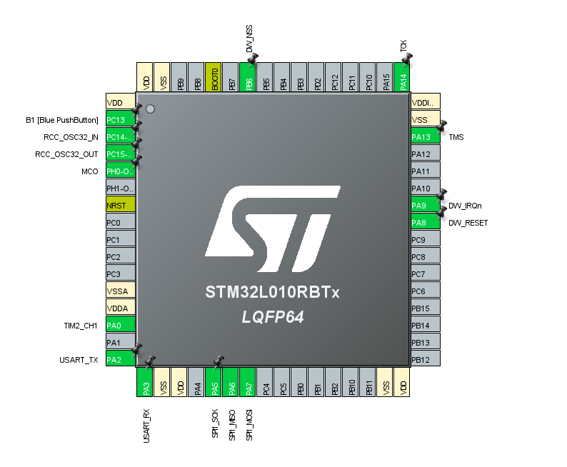Figura 4: Pinout respondera

Kod główny(main.c):

/* USER CODE BEGIN Header */

/**

******************************************************************************

* @file : main.c

* @brief : Main program body

******************************************************************************

* @attention

*

* <h2><center>&copy; Copyright (c) 2021 STMicroelectronics.

* All rights reserved.</center></h2>

*

* This software component is licensed by ST under BSD 3-Clause license,

* the "License"; You may not use this file except in compliance with the

* License. You may obtain a copy of the License at:

* opensource.org/licenses/BSD-3-Clause

*

******************************************************************************

*/

/* USER CODE END Header */

/* Includes ------------------------------------------------------------------*/

**#include** "main.h"

/* Private includes ----------------------------------------------------------*/

/* USER CODE BEGIN Includes */

//main ex

**#include** "platform/port.h"

**app_t** app;

//end of main ex

**#include** <string.h>

**#include** "decadriver/deca_device_api.h"

**#include** "decadriver/deca_regs.h"

**#include** "platform/stdio.h"

**#include** "platform/deca_spi.h"

**#include** "platform/port.h"

/* USER CODE END Includes */

/* Private typedef -----------------------------------------------------------*/

/* USER CODE BEGIN PTD */

/* USER CODE END PTD */

/* Private define ------------------------------------------------------------*/

/* USER CODE BEGIN PD */

/* USER CODE END PD */

/* Private macro -------------------------------------------------------------*/

/* USER CODE BEGIN PM */

/* USER CODE END PM */

/* Private variables ---------------------------------------------------------*/

**SPI_HandleTypeDef** hspi1;

**TIM_HandleTypeDef** htim2;

**UART_HandleTypeDef** huart2;

/* USER CODE BEGIN PV */

/* USER CODE END PV */

/* Private function prototypes -----------------------------------------------*/

**void** **SystemClock_Config**(**void**);

**static** **void** **MX_GPIO_Init**(**void**);

**static** **void** **MX_SPI1_Init**(**void**);

**static** **void** **MX_TIM2_Init**(**void**);

**static** **void** **MX_USART2_UART_Init**(**void**);

/* USER CODE BEGIN PFP */

/* USER CODE END PFP */

/* Private user code ---------------------------------------------------------*/

/* USER CODE BEGIN 0 */

/* Example application name and version to display. */

**#define** **APP_NAME** "SS TWR RESP v1.2"

/* Default communication configuration. We use here EVK1000's mode 4. See NOTE 1 below. */

**static** **dwt_config_t** config = {

2, /* Channel number. */

DWT_PRF_64M, /* Pulse repetition frequency. */

DWT_PLEN_128, /* Preamble length. Used in TX only. */

DWT_PAC8, /* Preamble acquisition chunk size. Used in RX only. */

9, /* TX preamble code. Used in TX only. */

9, /* RX preamble code. Used in RX only. */

0, /* 0 to use standard SFD, 1 to use non-standard SFD. */

DWT_BR_6M8, /* Data rate. */

DWT_PHRMODE_STD, /* PHY header mode. */

(129 + 8 - 8) /* SFD timeout (preamble length + 1 + SFD length - PAC size). Used in RX only. */

};

/* Default antenna delay values for 64 MHz PRF. See NOTE 2 below. */

**#define** **TX_ANT_DLY** 16505

**#define** **RX_ANT_DLY** 16505

/* Frames used in the ranging process. See NOTE 3 below. */

**static** **uint8** rx_poll_msg[] = {0x41, 0x88, 0, 0xCA, 0xDE, 'W', 'A', 'V', 'E', 0xE0, 0, 0};

**static** **uint8** tx_resp_msg[] = {0x41, 0x88, 0, 0xCA, 0xDE, 'V', 'E', 'W', 'A', 0xE1, 0, 0, 0, 0, 0, 0, 0, 0, 0, 0};

/* Length of the common part of the message (up to and including the function code, see NOTE 3 below). */

**#define** **ALL_MSG_COMMON_LEN** 10

/* Index to access some of the fields in the frames involved in the process. */

**#define** **ALL_MSG_SN_IDX** 2

**#define** **RESP_MSG_POLL_RX_TS_IDX** 10

**#define** **RESP_MSG_RESP_TX_TS_IDX** 14

**#define** **RESP_MSG_TS_LEN** 4

/* Frame sequence number, incremented after each transmission. */

**static** **uint8** frame_seq_nb = 0;

/* Buffer to store received messages.

* Its size is adjusted to longest frame that this example code is supposed to handle. */

**#define** **RX_BUF_LEN** 12

**static** **uint8** rx_buffer[RX_BUF_LEN];

/* Hold copy of status register state here for reference so that it can be examined at a debug breakpoint. */

**static** **uint32** status_reg = 0;

/* UWB microsecond (uus) to device time unit (dtu, around 15.65 ps) conversion factor.

* 1 uus = 512 / 499.2 µs and 1 µs = 499.2 * 128 dtu. */

**#define** **UUS_TO_DWT_TIME** 147456

/* Delay between frames, in UWB microseconds. See NOTE 1 below. */

**#define** **POLL_RX_TO_RESP_TX_DLY_UUS** 330

/* Timestamps of frames transmission/reception.

* As they are 40-bit wide, we need to define a 64-bit int type to handle them. */

**typedef** **unsigned** **long** **long** **uint64**;

**static** **uint64** poll_rx_ts;

**static** **uint64** resp_tx_ts;

/* Declaration of static functions. */

**static** **uint64** **get_rx_timestamp_u64**(**void**);

**static** **void** **resp_msg_set_ts**(**uint8** *ts_field, **const** **uint64** ts);

/* USER CODE END 0 */

/**

* @brief The application entry point.

* @retval int

*/

**int** **main**(**void**)

{

/* USER CODE BEGIN 1 */

/* USER CODE END 1 */

/* MCU Configuration--------------------------------------------------------*/

/* Reset of all peripherals, Initializes the Flash interface and the Systick. */

**HAL_Init**();

/* USER CODE BEGIN Init */

/* USER CODE END Init */

/* Configure the system clock */

**SystemClock_Config**();

/* USER CODE BEGIN SysInit */

/* USER CODE END SysInit */

/* Initialize all configured peripherals */

**MX_GPIO_Init**();

**MX_SPI1_Init**();

**MX_TIM2_Init**();

**MX_USART2_UART_Init**();

/* USER CODE BEGIN 2 */

//main ex

**setup_DW1000RSTnIRQ**(0);

**stdio_init**(&huart2);

**HAL_TIM_Base_Init**(&htim2);

//end of my ex

/* Display application name. */

**stdio_write**(APP_NAME);

/* Reset and initialise DW1000.

* For initialisation, DW1000 clocks must be temporarily set to crystal speed. After initialisation SPI rate can be increased for optimum

* performance. */

**reset_DW1000**(); /* Target specific drive of RSTn line into DW1000 low for a period. */

**port_set_dw1000_slowrate**();

**if** (**dwt_initialise**(DWT_LOADUCODE) == DWT_ERROR)

{

**stdio_write**("INIT FAILED");

**while** (1)

{ };

}

**port_set_dw1000_fastrate**();

/* Configure DW1000. See NOTE 5 below. */

**dwt_configure**(&config);

/* Apply default antenna delay value. See NOTE 2 below. */

**dwt_setrxantennadelay**(RX_ANT_DLY);

**dwt_settxantennadelay**(TX_ANT_DLY);

/* USER CODE END 2 */

/* Infinite loop */

/* USER CODE BEGIN WHILE */

**while** (1) {

/* Activate reception immediately. */

**dwt_rxenable**(DWT_START_RX_IMMEDIATE);

/* Poll for reception of a frame or error/timeout. See NOTE 6 below. */

**while** (!((status_reg = dwt_read32bitreg(SYS_STATUS_ID)) & (SYS_STATUS_RXFCG | SYS_STATUS_ALL_RX_ERR)))

{ };

**if** (status_reg & SYS_STATUS_RXFCG)

{

**uint32** frame_len;

/* Clear good RX frame event in the DW1000 status register. */

dwt_write32bitreg(SYS_STATUS_ID, SYS_STATUS_RXFCG);

/* A frame has been received, read it into the local buffer. */

frame_len = dwt_read32bitreg(RX_FINFO_ID) & RX_FINFO_RXFL_MASK_1023;

**if** (frame_len <= RX_BUFFER_LEN)

{

**dwt_readrxdata**(rx_buffer, frame_len, 0);

}

/* Check that the frame is a poll sent by "SS TWR initiator" example.

* As the sequence number field of the frame is not relevant, it is cleared to simplify the validation of the frame. */

rx_buffer[ALL_MSG_SN_IDX] = 0;

**if** (**memcmp**(rx_buffer, rx_poll_msg, ALL_MSG_COMMON_LEN) == 0)

{

**uint32** resp_tx_time;

**int** ret;

/* Retrieve poll reception timestamp. */

poll_rx_ts = **get_rx_timestamp_u64**();

/* Compute final message transmission time. See NOTE 7 below. */

resp_tx_time = (poll_rx_ts + (POLL_RX_TO_RESP_TX_DLY_UUS * UUS_TO_DWT_TIME)) >> 8;

**dwt_setdelayedtrxtime**(resp_tx_time);

/* Response TX timestamp is the transmission time we programmed plus the antenna delay. */

resp_tx_ts = (((**uint64**)(resp_tx_time & 0xFFFFFFFEUL)) << 8) + TX_ANT_DLY;

/* Write all timestamps in the final message. See NOTE 8 below. */

**resp_msg_set_ts**(&tx_resp_msg[RESP_MSG_POLL_RX_TS_IDX], poll_rx_ts);

**resp_msg_set_ts**(&tx_resp_msg[RESP_MSG_RESP_TX_TS_IDX], resp_tx_ts);

/* Write and send the response message. See NOTE 9 below. */

tx_resp_msg[ALL_MSG_SN_IDX] = frame_seq_nb;

**dwt_writetxdata**(**sizeof**(tx_resp_msg), tx_resp_msg, 0); /* Zero offset in TX buffer. */

**dwt_writetxfctrl**(**sizeof**(tx_resp_msg), 0, 1); /* Zero offset in TX buffer, ranging. */

ret = **dwt_starttx**(DWT_START_TX_DELAYED);

/* If dwt_starttx() returns an error, abandon this ranging exchange and proceed to the next one. See NOTE 10 below. */

**if** (ret == DWT_SUCCESS)

{

/* Poll DW1000 until TX frame sent event set. See NOTE 6 below. */

**while** (!(dwt_read32bitreg(SYS_STATUS_ID) & SYS_STATUS_TXFRS))

{ };

/* Clear TXFRS event. */

dwt_write32bitreg(SYS_STATUS_ID, SYS_STATUS_TXFRS);

/* Increment frame sequence number after transmission of the poll message (modulo 256). */

frame_seq_nb++;

}

}

}

**else**

{

/* Clear RX error events in the DW1000 status register. */

dwt_write32bitreg(SYS_STATUS_ID, SYS_STATUS_ALL_RX_ERR);

/* Reset RX to properly reinitialise LDE operation. */

**dwt_rxreset**();

}

/* USER CODE END WHILE */

/* USER CODE BEGIN 3 */

}

/* USER CODE END 3 */

}

/**

* @brief System Clock Configuration

* @retval None

*/

**void** **SystemClock_Config**(**void**)

{

**RCC_OscInitTypeDef** RCC_OscInitStruct = {0};

**RCC_ClkInitTypeDef** RCC_ClkInitStruct = {0};

**RCC_PeriphCLKInitTypeDef** PeriphClkInit = {0};

/** Configure the main internal regulator output voltage

*/

__HAL_PWR_VOLTAGESCALING_CONFIG(PWR_REGULATOR_VOLTAGE_SCALE1);

/** Initializes the RCC Oscillators according to the specified parameters

* in the RCC_OscInitTypeDef structure.

*/

RCC_OscInitStruct.OscillatorType = RCC_OSCILLATORTYPE_HSI;

RCC_OscInitStruct.HSIState = RCC_HSI_ON;

RCC_OscInitStruct.HSICalibrationValue = RCC_HSICALIBRATION_DEFAULT;

RCC_OscInitStruct.PLL.PLLState = RCC_PLL_ON;

RCC_OscInitStruct.PLL.PLLSource = RCC_PLLSOURCE_HSI;

RCC_OscInitStruct.PLL.PLLMUL = RCC_PLLMUL_4;

RCC_OscInitStruct.PLL.PLLDIV = RCC_PLLDIV_2;

**if** (**HAL_RCC_OscConfig**(&RCC_OscInitStruct) != *HAL_OK*)

{

**Error_Handler**();

}

/** Initializes the CPU, AHB and APB buses clocks

*/

RCC_ClkInitStruct.ClockType = RCC_CLOCKTYPE_HCLK|RCC_CLOCKTYPE_SYSCLK

|RCC_CLOCKTYPE_PCLK1|RCC_CLOCKTYPE_PCLK2;

RCC_ClkInitStruct.SYSCLKSource = RCC_SYSCLKSOURCE_PLLCLK;

RCC_ClkInitStruct.AHBCLKDivider = RCC_SYSCLK_DIV1;

RCC_ClkInitStruct.APB1CLKDivider = RCC_HCLK_DIV1;

RCC_ClkInitStruct.APB2CLKDivider = RCC_HCLK_DIV1;

**if** (**HAL_RCC_ClockConfig**(&RCC_ClkInitStruct, FLASH_LATENCY_1) != *HAL_OK*)

{

**Error_Handler**();

}

PeriphClkInit.PeriphClockSelection = RCC_PERIPHCLK_USART2;

PeriphClkInit.Usart2ClockSelection = RCC_USART2CLKSOURCE_PCLK1;

**if** (**HAL_RCCEx_PeriphCLKConfig**(&PeriphClkInit) != *HAL_OK*)

{

**Error_Handler**();

}

}

/**

* @brief SPI1 Initialization Function

* @param None

* @retval None

*/

**static** **void** **MX_SPI1_Init**(**void**)

{

/* USER CODE BEGIN SPI1_Init 0 */

/* USER CODE END SPI1_Init 0 */

/* USER CODE BEGIN SPI1_Init 1 */

/* USER CODE END SPI1_Init 1 */

/* SPI1 parameter configuration*/

hspi1.Instance = SPI1;

hspi1.Init.Mode = SPI_MODE_MASTER;

hspi1.Init.Direction = SPI_DIRECTION_2LINES;

hspi1.Init.DataSize = SPI_DATASIZE_8BIT;

hspi1.Init.CLKPolarity = SPI_POLARITY_LOW;

hspi1.Init.CLKPhase = SPI_PHASE_1EDGE;

hspi1.Init.NSS = SPI_NSS_SOFT;

hspi1.Init.BaudRatePrescaler = SPI_BAUDRATEPRESCALER_4;

hspi1.Init.FirstBit = SPI_FIRSTBIT_MSB;

hspi1.Init.TIMode = SPI_TIMODE_DISABLE;

hspi1.Init.CRCCalculation = SPI_CRCCALCULATION_DISABLE;

hspi1.Init.CRCPolynomial = 7;

**if** (**HAL_SPI_Init**(&hspi1) != *HAL_OK*)

{

**Error_Handler**();

}

/* USER CODE BEGIN SPI1_Init 2 */

/* USER CODE END SPI1_Init 2 */

}

/**

* @brief TIM2 Initialization Function

* @param None

* @retval None

*/

**static** **void** **MX_TIM2_Init**(**void**)

{

/* USER CODE BEGIN TIM2_Init 0 */

/* USER CODE END TIM2_Init 0 */

**TIM_SlaveConfigTypeDef** sSlaveConfig = {0};

**TIM_MasterConfigTypeDef** sMasterConfig = {0};

**TIM_OC_InitTypeDef** sConfigOC = {0};

/* USER CODE BEGIN TIM2_Init 1 */

/* USER CODE END TIM2_Init 1 */

htim2.Instance = TIM2;

htim2.Init.Prescaler = 0;

htim2.Init.CounterMode = TIM_COUNTERMODE_UP;

htim2.Init.Period = 65535;

htim2.Init.ClockDivision = TIM_CLOCKDIVISION_DIV1;

htim2.Init.AutoReloadPreload = TIM_AUTORELOAD_PRELOAD_DISABLE;

**if** (**HAL_TIM_Base_Init**(&htim2) != *HAL_OK*)

{

**Error_Handler**();

}

**if** (**HAL_TIM_OC_Init**(&htim2) != *HAL_OK*)

{

**Error_Handler**();

}

sSlaveConfig.SlaveMode = TIM_SLAVEMODE_TRIGGER;

sSlaveConfig.InputTrigger = TIM_TS_ITR0;

**if** (**HAL_TIM_SlaveConfigSynchro**(&htim2, &sSlaveConfig) != *HAL_OK*)

{

**Error_Handler**();

}

sMasterConfig.MasterOutputTrigger = TIM_TRGO_RESET;

sMasterConfig.MasterSlaveMode = TIM_MASTERSLAVEMODE_DISABLE;

**if** (**HAL_TIMEx_MasterConfigSynchronization**(&htim2, &sMasterConfig) != *HAL_OK*)

{

**Error_Handler**();

}

sConfigOC.OCMode = TIM_OCMODE_TIMING;

sConfigOC.Pulse = 0;

sConfigOC.OCPolarity = TIM_OCPOLARITY_HIGH;

sConfigOC.OCFastMode = TIM_OCFAST_DISABLE;

**if** (**HAL_TIM_OC_ConfigChannel**(&htim2, &sConfigOC, TIM_CHANNEL_1) != *HAL_OK*)

{

**Error_Handler**();

}

/* USER CODE BEGIN TIM2_Init 2 */

/* USER CODE END TIM2_Init 2 */

**HAL_TIM_MspPostInit**(&htim2);

}

/**

* @brief USART2 Initialization Function

* @param None

* @retval None

*/

**static** **void** **MX_USART2_UART_Init**(**void**)

{

/* USER CODE BEGIN USART2_Init 0 */

/* USER CODE END USART2_Init 0 */

/* USER CODE BEGIN USART2_Init 1 */

/* USER CODE END USART2_Init 1 */

huart2.Instance = USART2;

huart2.Init.BaudRate = 115200;

huart2.Init.WordLength = UART_WORDLENGTH_8B;

huart2.Init.StopBits = UART_STOPBITS_1;

huart2.Init.Parity = UART_PARITY_NONE;

huart2.Init.Mode = UART_MODE_TX_RX;

huart2.Init.HwFlowCtl = UART_HWCONTROL_NONE;

huart2.Init.OverSampling = UART_OVERSAMPLING_16;

huart2.Init.OneBitSampling = UART_ONE_BIT_SAMPLE_DISABLE;

huart2.AdvancedInit.AdvFeatureInit = UART_ADVFEATURE_NO_INIT;

**if** (**HAL_UART_Init**(&huart2) != *HAL_OK*)

{

**Error_Handler**();

}

/* USER CODE BEGIN USART2_Init 2 */

/* USER CODE END USART2_Init 2 */

}

/**

* @brief GPIO Initialization Function

* @param None

* @retval None

*/

**static** **void** **MX_GPIO_Init**(**void**)

{

**GPIO_InitTypeDef** GPIO_InitStruct = {0};

/* GPIO Ports Clock Enable */

__HAL_RCC_GPIOC_CLK_ENABLE();

__HAL_RCC_GPIOH_CLK_ENABLE();

__HAL_RCC_GPIOA_CLK_ENABLE();

__HAL_RCC_GPIOB_CLK_ENABLE();

/*Configure GPIO pin Output Level */

**HAL_GPIO_WritePin**(DW_RESET_GPIO_Port, DW_RESET_Pin, *GPIO_PIN_RESET*);

/*Configure GPIO pin Output Level */

**HAL_GPIO_WritePin**(DW_NSS_GPIO_Port, DW_NSS_Pin, *GPIO_PIN_SET*);

/*Configure GPIO pin : B1_Pin */

GPIO_InitStruct.Pin = B1_Pin;

GPIO_InitStruct.Mode = GPIO_MODE_IT_FALLING;

GPIO_InitStruct.Pull = GPIO_NOPULL;

**HAL_GPIO_Init**(B1_GPIO_Port, &GPIO_InitStruct);

/*Configure GPIO pin : DW_RESET_Pin */

GPIO_InitStruct.Pin = DW_RESET_Pin;

GPIO_InitStruct.Mode = GPIO_MODE_OUTPUT_OD;

GPIO_InitStruct.Pull = GPIO_NOPULL;

GPIO_InitStruct.Speed = GPIO_SPEED_FREQ_LOW;

**HAL_GPIO_Init**(DW_RESET_GPIO_Port, &GPIO_InitStruct);

/*Configure GPIO pin : DW_IRQn_Pin */

GPIO_InitStruct.Pin = DW_IRQn_Pin;

GPIO_InitStruct.Mode = GPIO_MODE_IT_RISING;

GPIO_InitStruct.Pull = GPIO_PULLDOWN;

**HAL_GPIO_Init**(DW_IRQn_GPIO_Port, &GPIO_InitStruct);

/*Configure GPIO pin : DW_NSS_Pin */

GPIO_InitStruct.Pin = DW_NSS_Pin;

GPIO_InitStruct.Mode = GPIO_MODE_OUTPUT_PP;

GPIO_InitStruct.Pull = GPIO_NOPULL;

GPIO_InitStruct.Speed = GPIO_SPEED_FREQ_LOW;

**HAL_GPIO_Init**(DW_NSS_GPIO_Port, &GPIO_InitStruct);

/* EXTI interrupt init*/

**HAL_NVIC_SetPriority**(*EXTI4_15_IRQn*, 0, 0);

**HAL_NVIC_EnableIRQ**(*EXTI4_15_IRQn*);

}

/* USER CODE BEGIN 4 */

/*! ------------------------------------------------------------------------------------------------------------------

* @fn get_rx_timestamp_u64()

*

* @brief Get the RX time-stamp in a 64-bit variable.

* /!\ This function assumes that length of time-stamps is 40 bits, for both TX and RX!

*

* @param none

*

* @return 64-bit value of the read time-stamp.

*/

**static** **uint64** **get_rx_timestamp_u64**(**void**)

{

**uint8** ts_tab[5];

**uint64** ts = 0;

**int** i;

**dwt_readrxtimestamp**(ts_tab);

**for** (i = 4; i >= 0; i--)

{

ts <<= 8;

ts |= ts_tab[i];

}

**return** ts;

}

/*! ------------------------------------------------------------------------------------------------------------------

* @fn final_msg_set_ts()

*

* @brief Fill a given timestamp field in the response message with the given value. In the timestamp fields of the

* response message, the least significant byte is at the lower address.

*

* @param ts_field pointer on the first byte of the timestamp field to fill

* ts timestamp value

*

* @return none

*/

**static** **void** **resp_msg_set_ts**(**uint8** *ts_field, **const** **uint64** ts)

{

**int** i;

**for** (i = 0; i < RESP_MSG_TS_LEN; i++)

{

ts_field[i] = (ts >> (i * 8)) & 0xFF;

}

}

/* USER CODE END 4 */

/**

* @brief This function is executed in case of error occurrence.

* @retval None

*/

**void** **Error_Handler**(**void**)

{

/* USER CODE BEGIN Error_Handler_Debug */

/* User can add his own implementation to report the HAL error return state */

**__disable_irq**();

**while** (1) {

}

/* USER CODE END Error_Handler_Debug */

}

**#ifdef** USE_FULL_ASSERT

/**

* @brief Reports the name of the source file and the source line number

* where the assert_param error has occurred.

* @param file: pointer to the source file name

* @param line: assert_param error line source number

* @retval None

*/

**void** assert_failed(uint8_t *file, uint32_t line)

{

/* USER CODE BEGIN 6 */

/* User can add his own implementation to report the file name and line number,

ex: printf("Wrong parameters value: file %s on line %d\r\n", file, line) */

/* USER CODE END 6 */

}

**#endif** /* USE_FULL_ASSERT */

/************************ (C) COPYRIGHT STMicroelectronics *****END OF FILE****/

#### Wnioski

Układ działa poprawnie. Umożliwia prosty odczyt dytansu pomiędzy inicjatorem a responderem. Wynik odczytu jest pokazywany na wyświetlaczu, a każdy z układów może być zasilany z powerbanka, dzięki czemu możliwe będzie testowanie trilateracji UWB na łodzi bez użycia komputera.

Wykonał: Bartosz Pracz